**Planning Committee meeting Monday 6th March 2023**

**Agenda item 5 – Royston Footpath 007 naming**

The Technical Project Officer at NHC has received an enquiry from a resident of Heath Avenue, Royston who would like to propose to name a Public Footpath that runs from Princes Mews to Heath Avenue and beyond that, onto Royston Heath.

A screen shot below marks the route. It’s the section from the bend westwards to its exit onto Briary Lane. Probably about 50 metres in length.

Apparently Princes Mews originally was the location for a stable yard and the jockeys and hands used to walk the racehorses along this footpath and onto the heath. The resident’s explanation is below.

“When we moved to Royston in 1971, we knew that Willie Stephenson had a stables in the town centre. We did not know that his horses, to be exercised, had to access the heath via Heath Avenue. So it was a delightful surprise to see a line of horses and jockeys crossing Briary Lane. They had emerged from what is now a footpath from Princes Mews. Later in the day the horses would return to the stables - sometimes without a jockey - who would be running after the horse that he started with. There is only about 50 yards of the original footpath left and we think it would be a nice historical gesture to name it JOCKEY WAY. We thank you in advance that this suggestion will find favour.”

As it’s a Public Footpath the officer has asked for the council’s thoughts on naming this section JOCKEY WAY.

The officer states -

“Implications are few as far as I can see. There are no residential addresses affected and I don’t think there would be any need to make an update to the Def Map. I would install a couple of Street Nameplates (once site surveyed). I’ve already spoken to an officer at HCC Public Rights of Way Unit and he is absolutely fine with the proposal.”

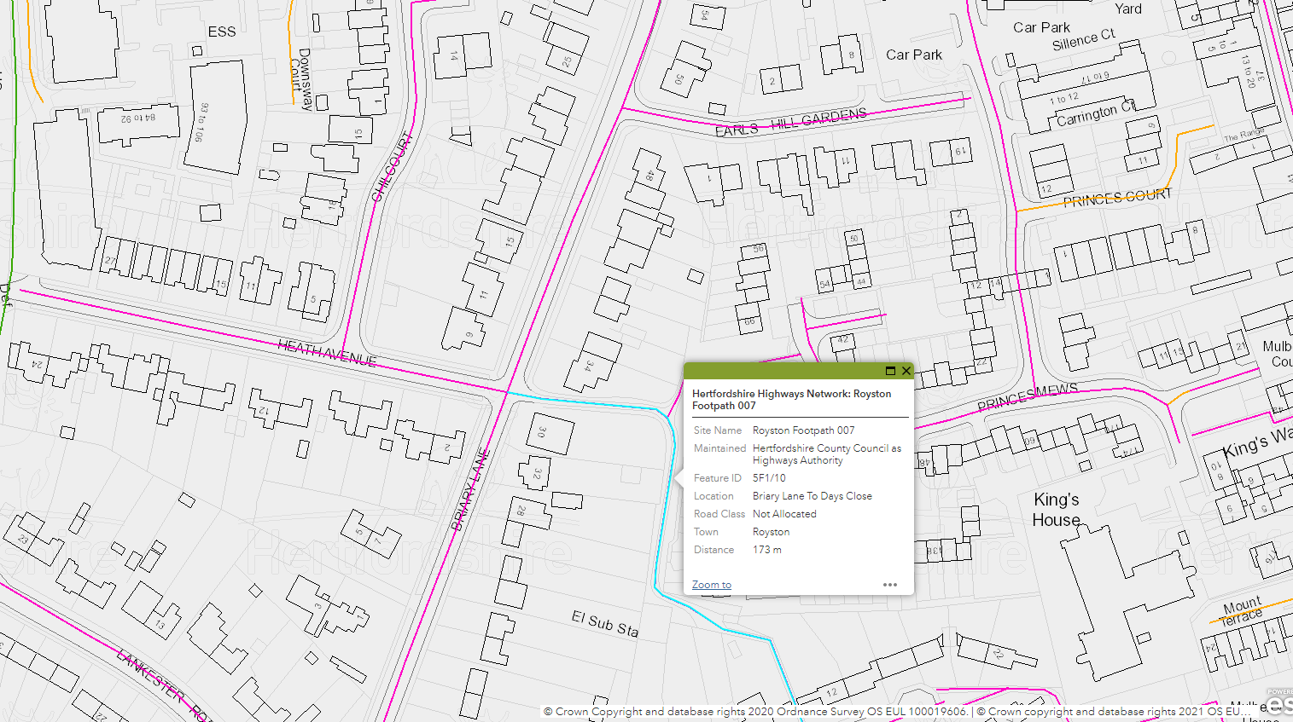

Members are to RESOLVE to agree that the section of Footpath 007 is named Jockey Way.